Perovskite solar cell in China
Introducing solar cell
Solar cell is a device that can directly converts solar energy into electrical energy. A basic structure for a solar cell can be demonstrated in Figure 1.
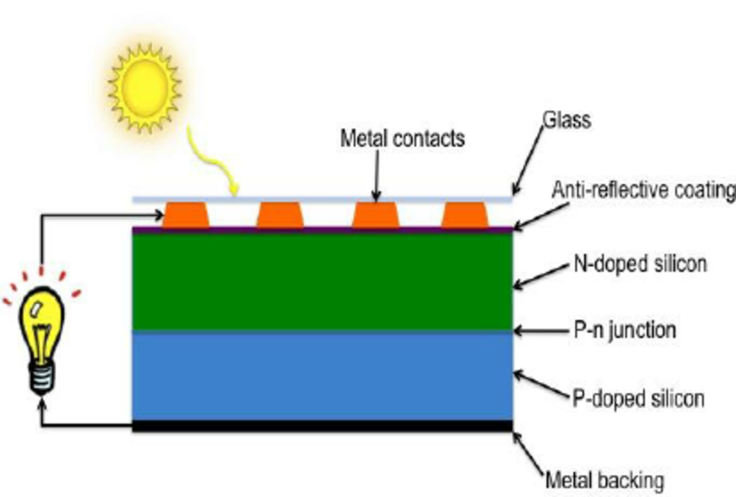
Figure 1. Schematic drawing of a silicon solar cell.
Usually, the n-type is made the emitter layer receiving sunlight. When the emitter layer absorbs enough solar energy greater than the bandgap energy, some of the electrons in the valence band will jump to the conduction band and leave a hole behind, creating an electron-hole pair. When the pair gets close to the depletion region, the hole will get swept across the junction by the electric field while the electron will be pushed away and travel to the load through the metal contact (Figure 2). This process is called collection. The two carriers will meet and recombine at the rear contact, after which the circuit has been completed.
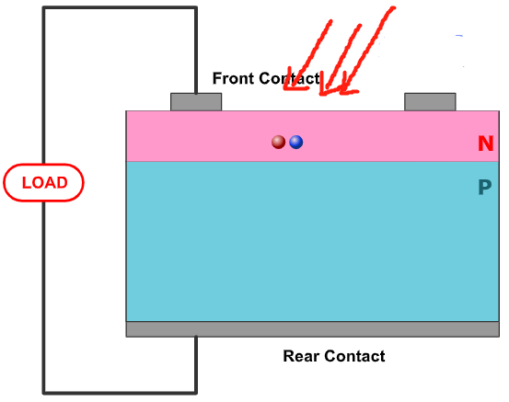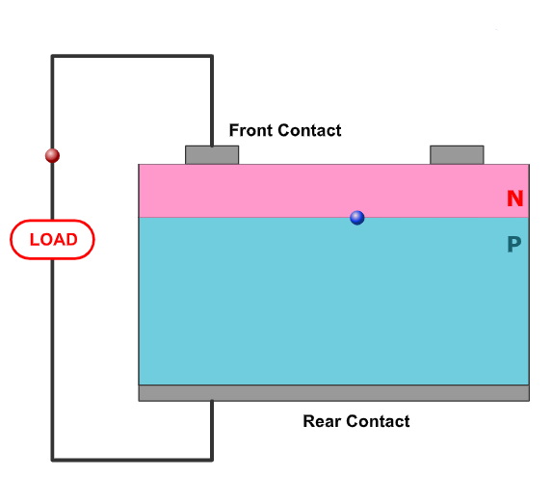
Figure 2. Movement of charge carriers inside a solar cell
However, the electron-hole pair can only exist for a length of time equal to the minority carrier lifetime before they recombine. The distance that the pair can travel during its life time is the diffusion length. If the pair is generated somewhere not close to the depletion region (distance to interface > diffusion length), the electron and the hole will recombine and thus provide no contribution to current generation. Therefore, lowering the chances for recombination can effectively improve the efficiency.
Perovskite Solar cell
Perovskite solar cell uses Perovskite as the light absorbing material. It has ABX3 crystal structure. Because perovskite has relatively lower recombination rate and higher carrier mobility, its carrier diffusion length and carrier lifetime is thus longer, improving the solar cell efficiency. A complete perovskite solar cell should also have HTL (hole transport layer) and ETL (electron transport layer) to facilitate the movement of carriers.
Perovskite, as a synthetic material, has made a big splash since 2009 when it was first tried to be used in photovoltaic power generation because of its excellent performance, low cost and great commercial value. In recent years, the world's top research institutions and large multinational companies, such as Oxford University, Swiss Federal Institute of Technology Lausanne, Japan's Panasonic, Sharp, Toshiba, etc., have invested a lot of manpower and resources to strive for early mass production.
In February 2017, Fibrina Optronics broke the world efficiency record of calcium-titanium ore panel with a conversion efficiency of 15.2% for the first time, which was previously held by Japan for a long time. After that, in May and December of that year, they broke the world record three times a year with 16% and 17.4% conversion efficiency respectively. This time, they increased the conversion efficiency of the perovskite module to 17.9%, with a steady-state output efficiency of 17.3%. The results once again demonstrate the technological leadership of Chinese scientists in the field of chalcogenide.

